**NAME: PRAKHAR MISHRA**

**DATE: 19/01/2024**

**QUESTIONS**

1. **Demonstration of SQL SELECT statement.**

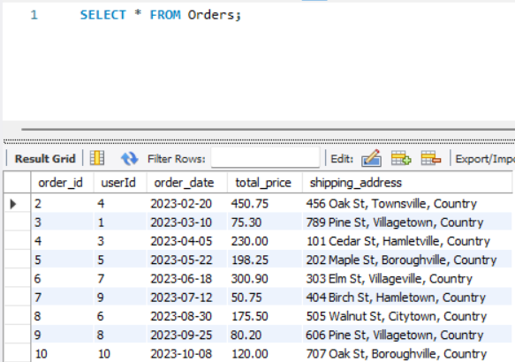

1. **Selecting specific column.**

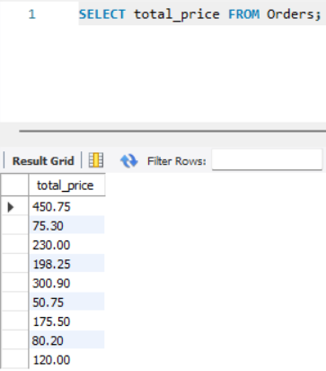

1. **Demonstration of DISTINCT statement.**

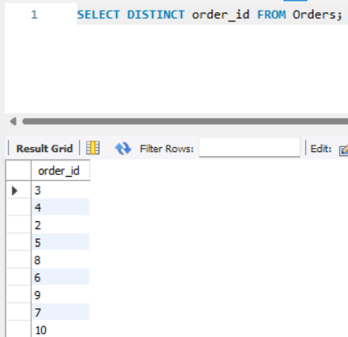

1. **Demonstration of HAVING Clause.**

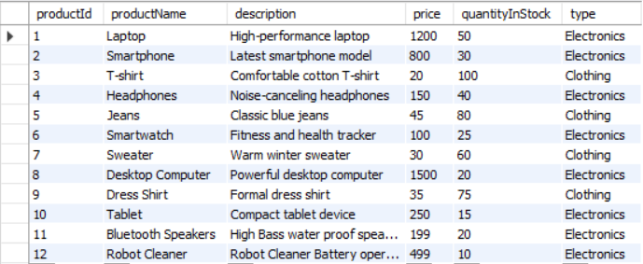

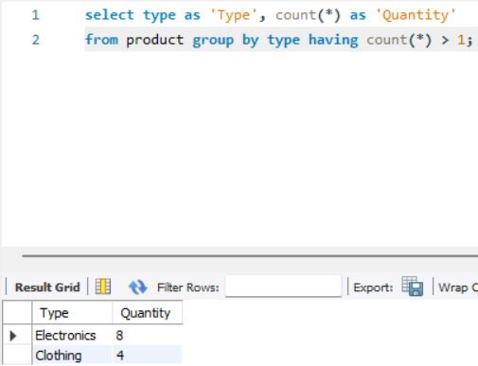

1. **Demonstration of GROUP BY clause.**



1. **Demonstration of UNION Operator.**

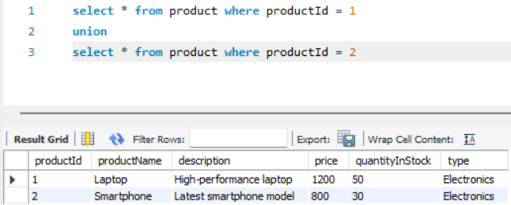

1. **Demonstration of UNION ALL operator.**

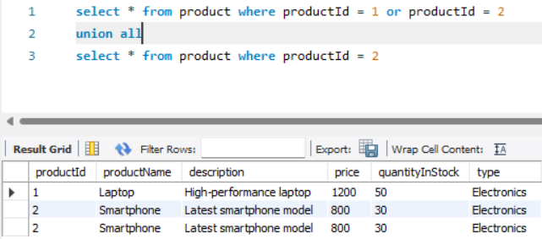

1. **Demonstration of INTERSECT (Supported in MS-SQL Server)**

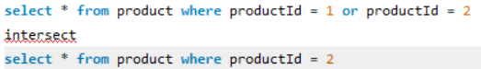

1. **Inserting Data into the database**

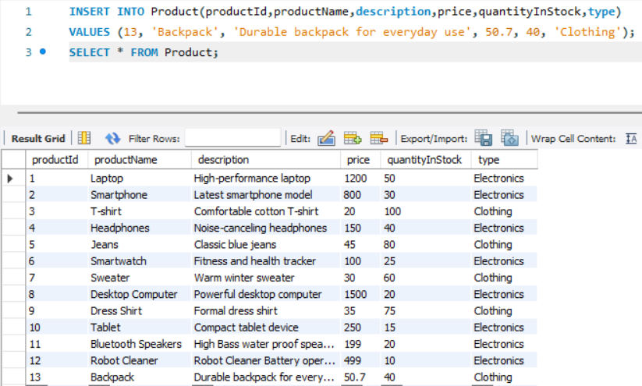

1. **Updating data in the table.**

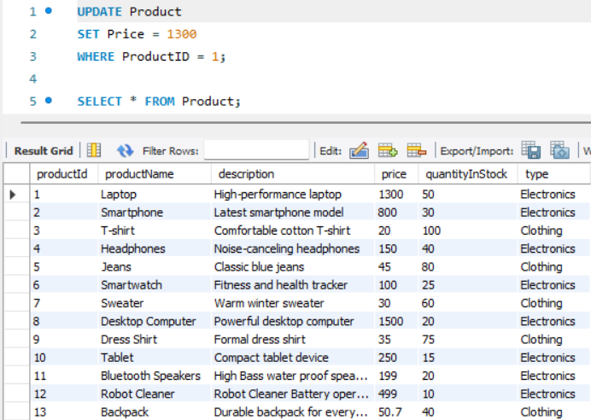

1. **Deleting data from the table.**

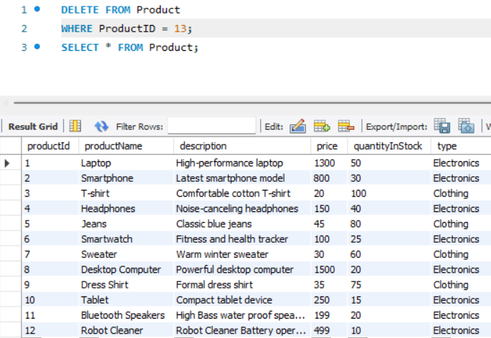

1. **Demonstration of IN Operator.**

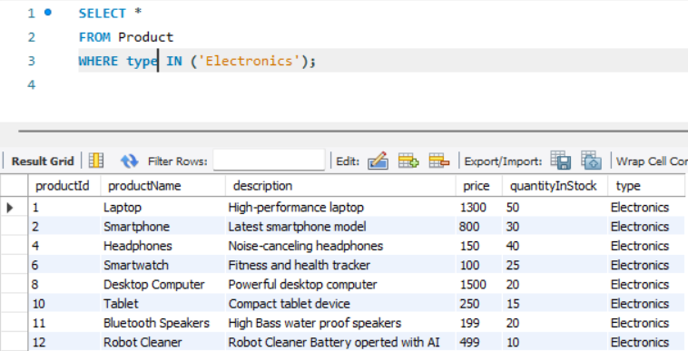

1. **Demonstration of BETWEEN Operator.**

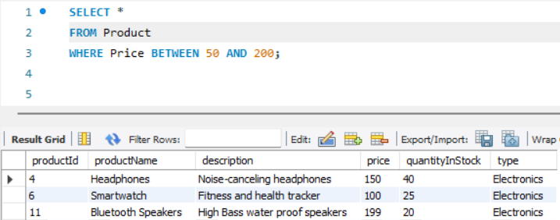

1. **Demonstration of LIKE Operator.**

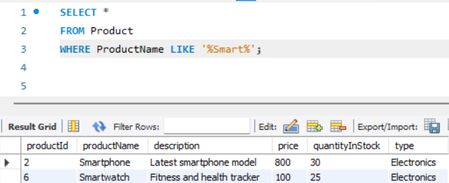

1. **Demonstration of Aliases.**

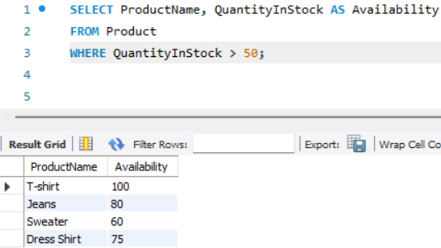

1. **Demonstration of String functions.**

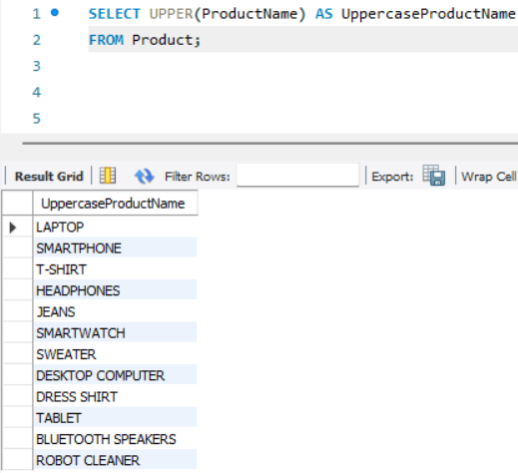

1. **Demonstration of Date Function.**

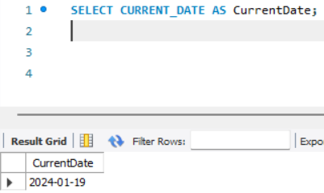

1. **Demonstration of Mathematical Functions.**

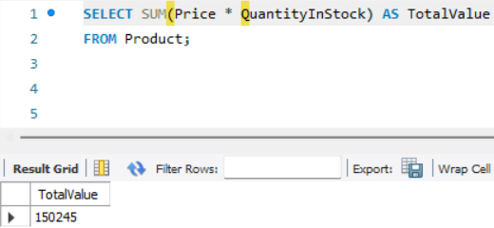

1. **Demonstration of System Functions.**

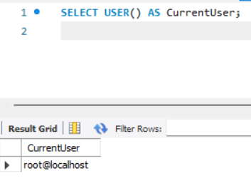

1. **Demonstration of Data Aggregation Functions.**

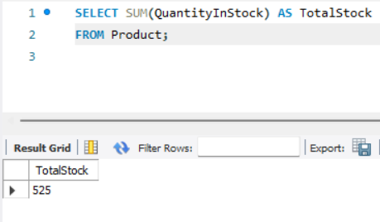

1. **Demonstration of Inner Join.**

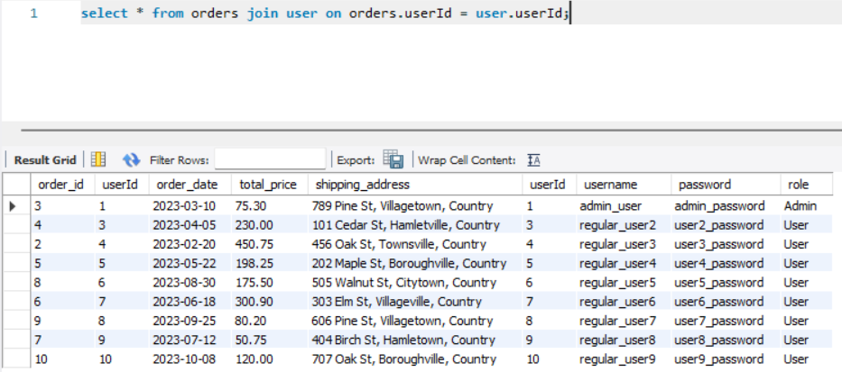

1. **Demonstration of Left Join.**

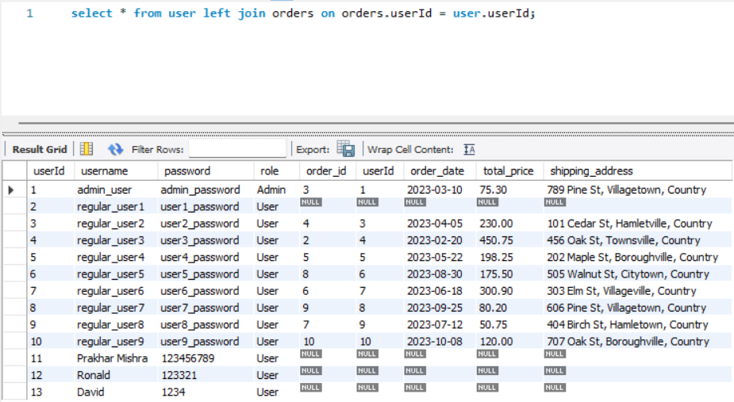

1. **Demonstration of Right Join.**

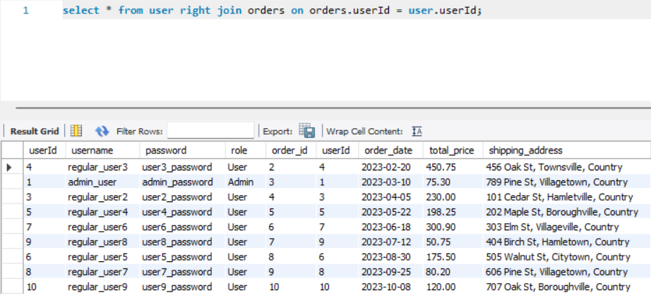

1. **Demonstration of Full Outer Join.**

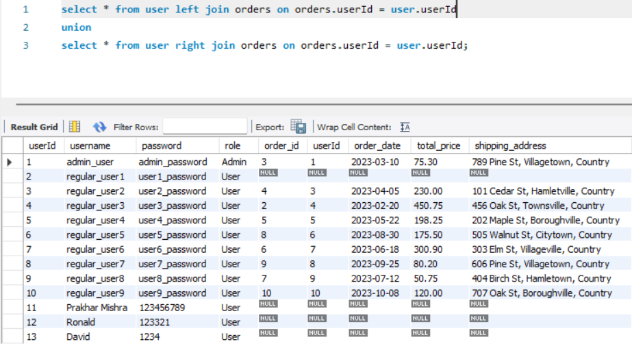

1. **Demonstration of Cross join.**

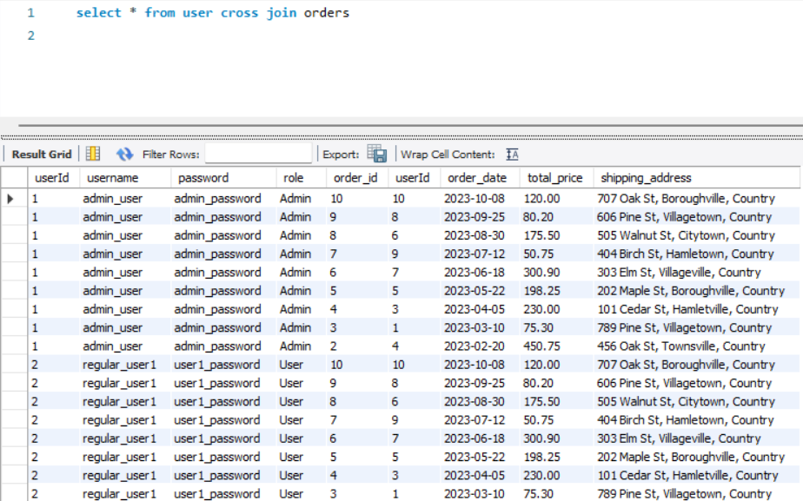

1. **Demonstration of Equi Join.**

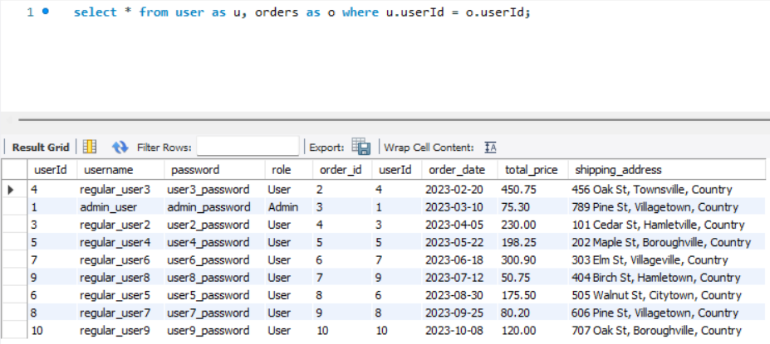

1. **Demonstration of Self Join.**

